**NVR301-04LS2-P4**

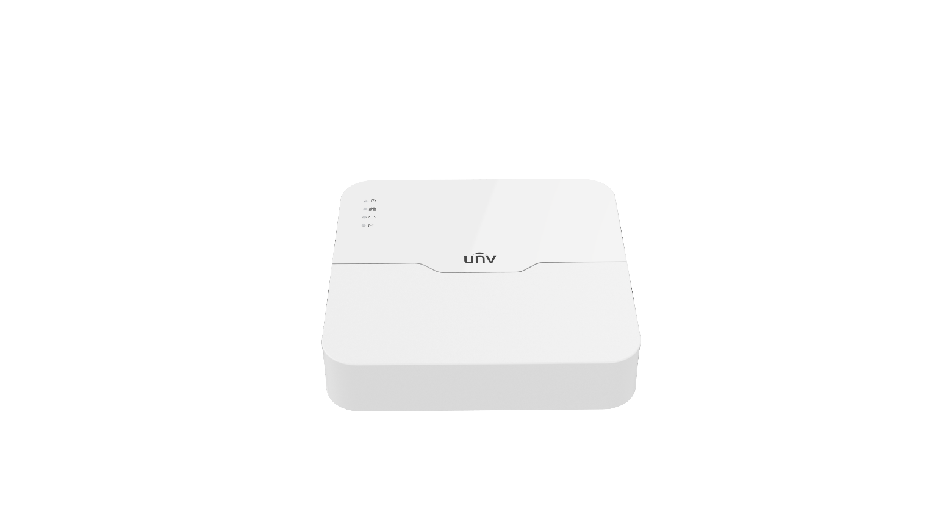

## Key Features

* Support Ultra 265/H.265/H.264 video formats
* 4-channel input
* Third-party IP cameras supported with ONVIF conformance: Profile S, Profile G, Profile T
* Support 1-ch HDMI, 1-ch VGA
* HDMI and VGA simultaneous output
* Up to 6MP resolution recording
* 1 SATA HDD up to 6 TB
* Support cloud upgrade

## Specifications

|  |  |
| --- | --- |
| **Model** | **NVR301-04LS2-P4** |
| Video/Audio Input | |
| IP Video Input | 4-ch |
| Network | |
| Incoming Bandwidth | 40Mbps |
| Outgoing Bandwidth | 40Mbps |
| Remote Users | 128 |
| Protocols | P2P, UPnP, NTP, DHCP, PPPoE |
| Video/Audio Output | |
| HDMI/VGA Output | HDMI:  1920x1080p/60Hz, 1920x1080p/50Hz, 1600x1200/60Hz, 1280x1024/60Hz, 1280x720/60Hz, 1024x768/60Hz  VGA:  1920x1080p/60Hz, 1920x1080p/50Hz, 1600x1200/60Hz, 1280x1024/60Hz, 1280x720/60Hz, 1024x768/60Hz |
| Recording Resolution | 6MP/5MP/4MP/3MP/1080p/960p/720p/D1/2CIF/CIF |
| Synchronous Playback | 4-ch |
| Corridor Mode Screen | 3/4 |
| Decoding | |
| Decoding format | Ultra 265/H.265/H.264 |
| Liveview/Playback | 6MP/5MP/4MP/3MP/1080p/960p/720p/D1/2CIF/CIF |
| Capability | 1 x 6MP@20, 1 x 5MP@30, 2 x 4MP@25, 2 x 3MP@30,4 x 1080p@25, 8 x 960p@25,8 x 720p@30 |
| Hard Disk | |
| SATA | 1 SATA interface |
| Capacity | up to 6TB for each disk |
| External Interface | |
| Network Interface | 1 RJ45 10M/100M self-adaptive Ethernet Interface |
| USB Interface | Rear panel: 2 x USB2.0 |
| Supported Standard | IEEE 802.3at, IEEE 802.3af |
| External Interface | |
| Interface | 4 RJ45 10M/100M self-adaptive Ethernet Interface |
| Max Power | Max 30W for single port  Max 54W in total |
| Supported Standard | IEEE 802.3at, IEEE 802.3af |
| General | |
| Power Supply | 48V DC  Power Consumption: ≤10 W (without HDD) |
| Working Environment | -10°C ~ + 55°C (+14°F ~ +131°F), Humidity ≤ 90% RH (non-condensing) |
| Dimensions (W×D×H) | 205mm × 205mm × 46mm (8.1"×8.1"×1.8") |
| Weight (without HDD) | 0.6kg (1.32 lb) |

## Dimensions

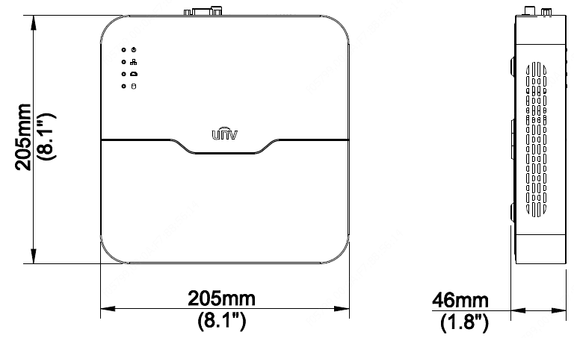

## Rear Panel



Zhejiang Uniview Technologies Co., Ltd.

Building No.10, Wanlun Science Park, Jiangling Road 88, Binjiang District, Hangzhou, Zhejiang, China

Email: [overseasbusiness@uniview.com](mailto:overseasbusiness@uniview.com); globalsupport@uniview.com

http://www.uniview.com

©2019 Zhejiang Uniview Technologies Co., Ltd. All rights reserved.

* Product specifications and availability are subject to change without notice.